Voice Order Agent – System Design
Oct 2, 2026 · @jame · Version 0.9.0

Purpose and scope
Voice Order Agent is a prototype: customers order food from an AI waiter by typing or speaking, and kitchen staff follow each order from received to delivered. It runs as one Python web server on a PC and is used in computer-science classes to show speech recognition, AI agents that use tools, and how text is stored as bytes.
- Version: 0.9.0, tag v0.9.0 in jamshideftekhari/VoiceRecognition.
- In scope: the desktop recorder (recorder.py), the terminal ordering agent (order_agent.py) and the web app with a customer page and a kitchen page (web_app.py).
- Out of scope: payment, user accounts, integration with a real kitchen or POS system, and production hosting.
- Readers: developers who extend the prototype.

System overview
The system is one Flask web server on a PC. The browser pages call its JSON API; the server recognizes speech locally with Whisper, sends the conversation to Claude, and saves orders as JSON files.
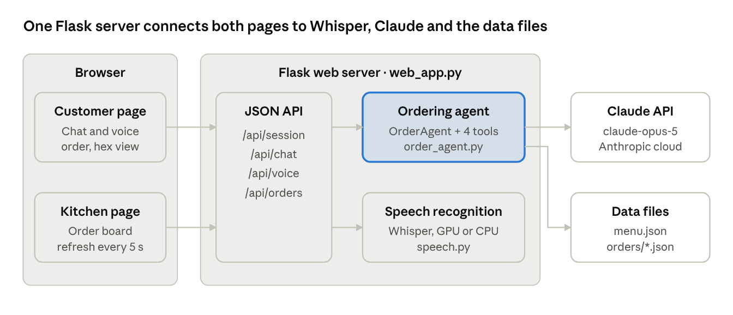
architecture · 2 pages, 1 server, 2 modules, 2 outside parts
The terminal chat (order_agent.py) and the desktop recorder (recorder.py) reuse the same ordering-agent and speech modules without the web server.

Components
The system has four Python modules, two web pages and two kinds of data files; the AI waiter runs in Anthropic's cloud, everything else runs locally.
Component | File | Responsibility | Depends on
Speech recognition | speech.py | Transcriber: loads a Whisper model, uses an NVIDIA GPU when available and falls back to the CPU, adds a vocabulary prompt. decode_audio: turns a browser recording into 16 kHz mono audio | faster-whisper, CTranslate2, PyAV, CUDA libraries (optional)
Desktop recorder | recorder.py | Tkinter app: record, play and save WAV; transcribe afterwards or live while speaking (LiveTranscriber); model, language and vocabulary settings | speech.py, sounddevice, SciPy
Ordering agent | order_agent.py | Menu, Order, the four tools, OrderAgent (Claude tool runner), order storage and status updates, terminal chat | Anthropic SDK, menu.json
Web server | web_app.py | Flask app: serves the pages and the JSON API, keeps chat sessions in memory, voice and kitchen endpoints | order_agent.py, speech.py, Flask
Customer page | static/index.html | Chat, push-to-talk, live order, clickable menu, hex view | Browser: fetch, MediaRecorder, TextEncoder
Kitchen page | static/orders.html | Order board with four status columns, refreshed every 5 seconds | /api/orders
Menu | menu.json | 12 dishes and drinks with prices in DKK, Danish names, descriptions and allergens | —
Placed orders | orders/*.json | One file per placed order, including its status history | —

Data model and storage
All lasting data is plain JSON files; conversations exist only in the server's memory. There is no database.
Menu item (menu.json): id, name, name_da, category, price, description, allergens (list) and vegetarian (true/false).
Placed order (orders/order-YYYYMMDD-HHMMSS[-n].json; the file name without .json is the order's id):
Field | Example | Meaning
order_number | "7" | Daily sequence starting at 1; shown to customer and kitchen
customer_name | "Jens" | Name the order is placed under
time | "2026-10-02T13:08:35" | When the order was placed (local time)
lines | item_id, name, quantity, notes, price, line_total | One entry per dish; notes holds special requests
total, currency | 235, "DKK" | Calculated in Python, never by the AI
status | "preparing" | received, preparing, ready or delivered
status_history | [{"status": "received", "time": "…"}, …] | Every status change with its time
Status rules: an order moves one step at a time, forward or back (to undo a mistake): received → preparing → ready → delivered. Files from before version 0.9.0 have no status and count as received. Status changes are written to a temporary file and then swapped in, so a reader never sees a half-written order.
Chat sessions (memory only): a random session id maps to one OrderAgent with its conversation history and basket. Sessions idle for 60 minutes are removed, and all sessions are lost when the server restarts.

Interfaces
The pages talk to the server through a small JSON API; every error comes back as {"error": "<message for the user>"} with the status code below.
Method and path | Request | Response | Errors
GET / | — | Customer page | —
GET /orders | — | Kitchen page | —
POST /api/session | empty | session_id, restaurant, greeting, menu, currency, order | —
POST /api/chat | session_id, text (max 1,000 characters) | reply, order, done | 400 empty text · 404 expired session · 409 order already placed or a reply still pending · 429 API rate limit · 502 API or network error
POST /api/voice | multipart: session_id, audio (max 10 MB, 0.3–60 s) | text, language, audio (seconds, samples, sample rate, upload bytes, 16-bit bytes) | 400 missing, unreadable, too short or too long · 404 · 409 · 413 too large · 422 no speech found
GET /api/orders | — | restaurant, orders (newest first), statuses, now (server time) | —
POST /api/orders/<id>/status | status | the updated order | 404 unknown order · 409 unknown status or not one step away
Command-line options
Program | Options
python web_app.py | --host (default 127.0.0.1; 0.0.0.0 = whole network), --port (default 5000), --https (self-signed certificate), --whisper-model, --language (da or en)
python order_agent.py | --debug (show tool calls), --hex (show messages as UTF-8 bytes)
python recorder.py | none; settings are in the window
Both web_app.py and order_agent.py need Anthropic credentials (ANTHROPIC_API_KEY or an ant auth login profile) and stop with a clear message without them.

Key flows
A spoken order is two requests: the page first gets the recognized text from /api/voice, shows it, and then sends it to /api/chat exactly like typed text. A typed order is the second half only.
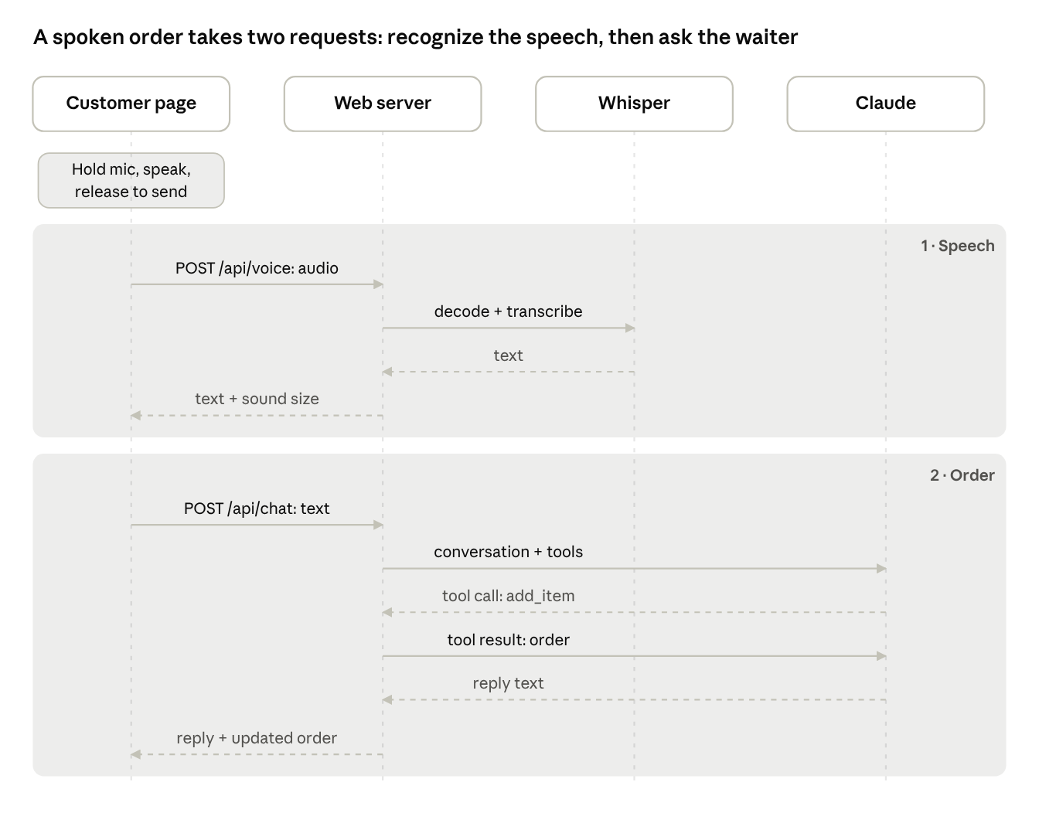
voice order sequence · 2 requests, tool loop inside the chat request
Inside /api/chat Claude may call several tools before it answers; the dashed arrows are replies. The page updates the basket from the order in the reply.
Placing an order and following it in the kitchen
- The customer says they are done; the waiter reads back the order and total and asks for confirmation and a name.
- On a clear yes, Claude calls place_order; the server saves orders/order-….json with status received and the next daily number.
- The customer page shows "Order placed — number N" and locks the chat.
- Within 5 seconds the kitchen page shows the new order, briefly highlighted, in Received.
- Staff click Start preparing, Mark ready and Mark delivered; each click is saved with its time in status_history.

AI agent design
Claude runs the conversation, but it can only change an order through four Python tools; the basket and every price live in Python. This keeps totals correct and stops the AI from ordering dishes that don't exist.
Tool | What it does | Guards
add_item(item, quantity, notes) | Adds a dish; same dish with the same notes is merged into one line | Name must match the menu; quantity at least 1
remove_item(line_number, quantity) | Removes a line, or reduces its quantity | Line number must exist
view_order() | Returns the order with line numbers and total | —
place_order(customer_name) | Saves the order to orders/ and returns its number | Basket not empty; can't be placed twice
Every tool returns the updated order as text, so Claude always sees the real state. A failed tool call returns an error message to Claude, which then explains it to the customer.
- Model and settings: claude-opus-5 with effort: low for quick replies, prompt caching for the menu and instructions, max_iterations 10 per turn, and server-side fallbacks (fallbacks: "default") if a request is declined.
- Loop: the Anthropic SDK's tool runner calls Claude, runs the requested tools and repeats until Claude answers in text.
- Instructions (system prompt): short spoken-style replies; ask instead of guessing; answer in the customer's language; only menu items; special requests as notes; prices only from the menu or a tool; allergens only from the menu; read back the order and total and get a clear yes before place_order.
- Menu in the prompt: the whole menu is part of the instructions instead of a get_menu tool, which saves one round trip per order.
- Name matching: names are compared without case, _ and -, against id, English and Danish names, then by similarity (cutoff 0.6). An unclear match returns up to 3 suggestions.
- History: each session keeps the full conversation including tool calls. If a turn fails, it is rolled back so the customer can simply repeat it.
- Cost (estimate, not measured): roughly $0.05–0.15 per order at $5 / $25 per million input / output tokens; caching lowers it.

Speech recognition design
Speech is recognized locally with Whisper (faster-whisper) at 16 kHz mono; no audio is sent to the cloud. On the development PC's NVIDIA RTX A1000 a 5.4-second spoken order is recognized in about 1 second.
Setting | Web app (push-to-talk) | Desktop recorder
Model | large-v3-turbo on GPU, base on CPU; --whisper-model overrides | Chosen in the window, default base
Device | NVIDIA GPU with float16 if found, else CPU with int8; falls back to CPU on a GPU error | Same
Language | Auto-detect, or --language da / en | Auto, Danish or English in the window
Vocabulary | Dish names from menu.json | Typed in the window
Silence filter | On: silence or noise gives "didn't catch that" | On for live text
Model loading | At server start | On first use
- Audio decoding: the browser sends WebM/Opus (or another format the browser records); speech.decode_audio decodes it with PyAV and resamples it to 16 kHz mono. It replaces faster_whisper.decode_audio, which fails with PyAV 19.
- Vocabulary prompt: the words are passed as Whisper's initial prompt with a full stop added, because without punctuation in the prompt Whisper dropped punctuation in its output.
- Silence filter: without it, 2 seconds of silence was transcribed as "Sous-titrage ST' 501", a known Whisper hallucination.
- Live transcription (desktop only): about once a second the not-yet-final audio is transcribed with greedy decoding. Text becomes final after a pause of 1 second (measured from word timestamps), after 15 seconds of continuous speech (all but the last segment), or at 25 seconds (Whisper's limit is 30). The first confidently detected language is kept for the rest of the recording.
- Measured speeds: 23 seconds of speech took 0.6 s with base and 1.0 s with large-v3-turbo on the GPU; base on the CPU was about 6 times slower than on the GPU.

Non-functional design
The prototype is built for a classroom or a small local network, not the open internet.
Area | Design
Performance | Whisper model loaded once at start; menu and instructions cached by the Claude API; Claude runs at low effort. A spoken turn = recognition (about 1 s on the GPU) + Claude's reply time
Concurrency | Flask runs threaded. One message at a time per session (a second one gets 409); one transcription at a time on the shared model; a lock around saving orders and changing their status
Reliability | Status changes written to a temporary file and swapped in; a new order file is never overwritten; failed chat turns are rolled back; GPU errors fall back to the CPU
Security | API key stays on the server; text limited to 1,000 characters and uploads to 10 MB; order ids must match the file-name pattern, so no other files can be reached; all text on the pages is inserted as plain text, not HTML. The kitchen page has no login
Privacy | Recordings are not stored. Typed and recognized text goes to Anthropic's API. Order files contain customer names and are excluded from Git
Deployment | Default http://127.0.0.1:5000 on one PC. Other devices: --host 0.0.0.0 --https, because browsers only allow the microphone on localhost or HTTPS. Uses Flask's built-in server
Hardware | Windows 11 PC with an optional NVIDIA GPU (CUDA libraries from requirements-gpu.txt). A Raspberry Pi 5 is expected to work with base or small on the CPU (not tested)

Limitations, risks and future work
The main risks for classroom use are the open kitchen page and recognition errors in Danish; neither blocks a demonstration.
Limitation or risk | Effect | Possible next step
No login on the kitchen page | Anyone who can open the web app can change order statuses | Simple PIN or staff login
Sessions only in memory | A server restart ends every open conversation | Store sessions in files or a database
Flask's built-in server | Not suitable for the open internet | A production WSGI server behind HTTPS
Order numbers counted per process | The CLI and the web app placing orders in the same second could get the same number (files are never overwritten) | One shared order store
Whisper with Danish | base is weak at Danish; dish names can be misheard ("margarita") | small or large-v3-turbo, or a Whisper model fine-tuned on Danish
Depends on internet and the Claude API | No waiter without a connection or API key | Clear offline message (exists); local fallback is out of scope
Test coverage | Automated tests used a mocked Claude API; the browser pages have not been tested in a browser by the developer | Run the acceptance tests
Planned features: hands-free ordering (send on pause), spoken replies from the waiter, showing customers their order status, and a kitchen login.

